
a
Company
Logotype

Cone Beam Computed Tomography- Report



Porur Dental X-rays & CBCT

Patient Name : Mr. Mannar | Date of Report : 08.07.2024
Age/ Gender : 59 years/ Male | Region of Interest : CBCT Maxilla
Referring doctor: Dr. Sasikumar | Indication : Implant assessment
Clinical Notes: Nil
PATIENT INFORMATION

CBCT- Maxilla provided
CBCT – IMAGE DETAILS

RADIOGRAPHIC INTERPRETATION

- Completely missing crown and root portion in relation to 16, 17, 18, 24, 25, 26, 27, 28.
- The maxillary alveolar ridge is present with normal trabecular pattern.

IMPLANT ASSESSMENT

 | 11 region | 12 region | 13 region | 14 region | 21 region | 22 region | 23 region | 24 region
Sub-Crestal | 7.08 | 5.58 | 7.43 | 9.13 | 4.89 | 5.24 | 5.68 | 5.15
Mid- Crestal | 6.8 | 6.93 | 9.47 | 9.32 | 6.14 | 6.31 | 7.71 | 7.22
Distance between the alveolar ridge and Floor of the Nasal cavity (in mm) | 14.01 | 16.02 | 18.02 | 14.73 | 9.44 | 12.91 | 13.88 | 9.72

 | 15 region | 16 region | 17 region | 25 region | 26 region | 27 region
Sub-Crestal (in mm) | - | - | - | 4.77 | 6.56 | 8.19
Mid- Crestal (in mm) | - | - | - | 6.52 | - | -
Distance between the alveolar ridge and floor of the maxillary sinus (in mm) | 1.57 | 1.28 | 1.92 | 6.15 | 3.21 | 2.4

RADIOGRAPHIC IMPRESSION

- Partially edentulous maxillary arch.

Kindly correlate with clinical findings


IMAGES FOR REFERENCE

RECONSTRUCTED PANORAMIC VIEW
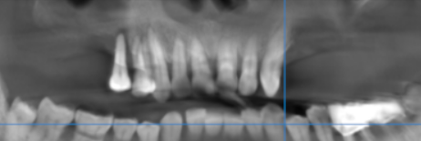

3-DIMENSIONAL VIEW

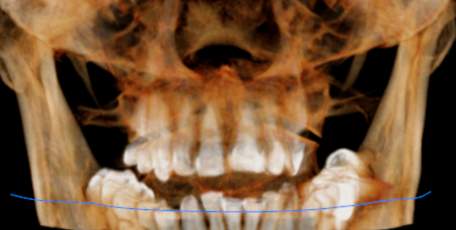

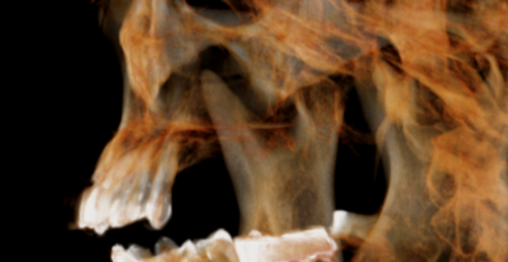
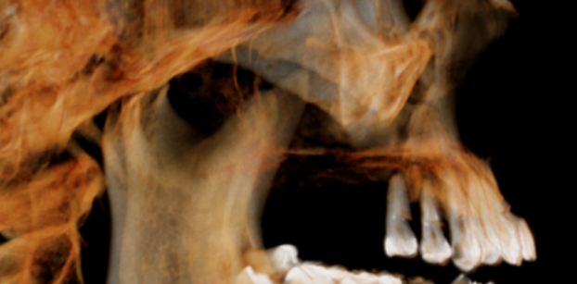

CROSS SECTIONAL VIEW

11 region | 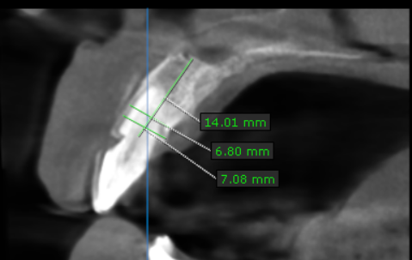
12 region | 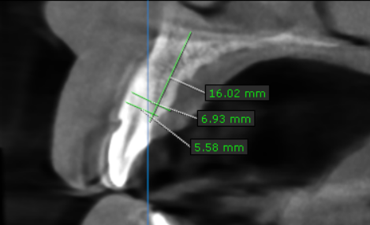
13 region | 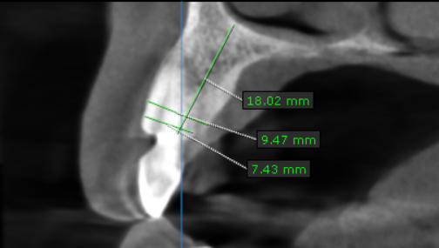
14 region | 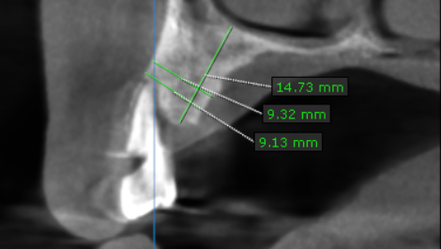
15 region | 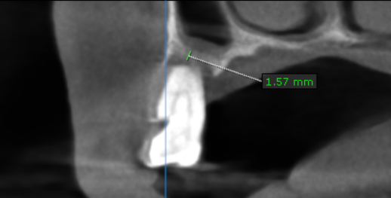
16 region | 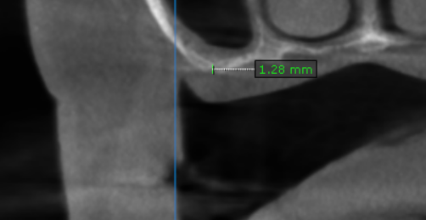
17 region | 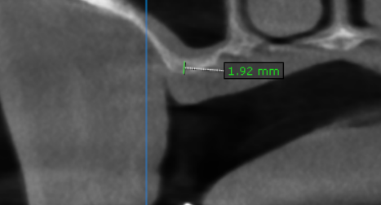
21 region | 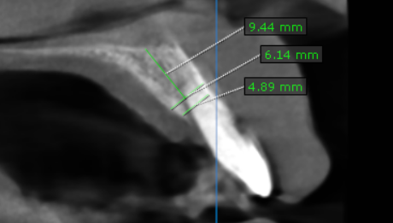
22 region | 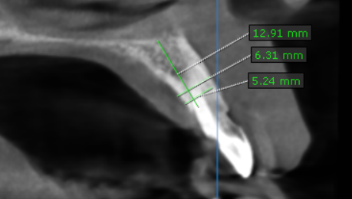
23 region | 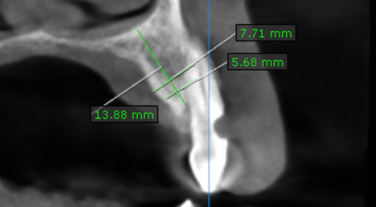
24 region | 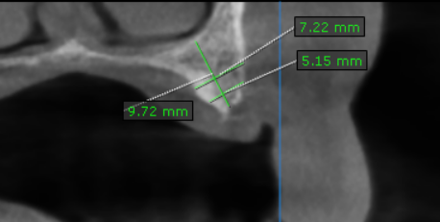
25 region | 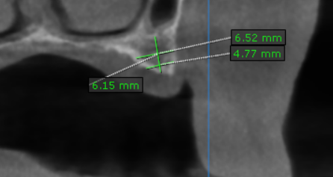
26 region | 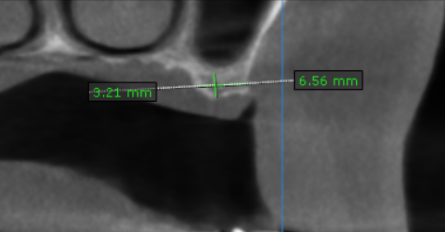
27 region | 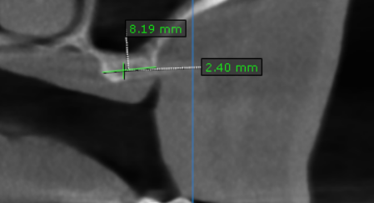

**** End of report ****

